Software Requirements Specification

for

Virtual Personal Assistant

**Version 1.0 approved**

**Prepared by 20CE041, 20CE043**

**CSPIT-CE**

**27-01-22**

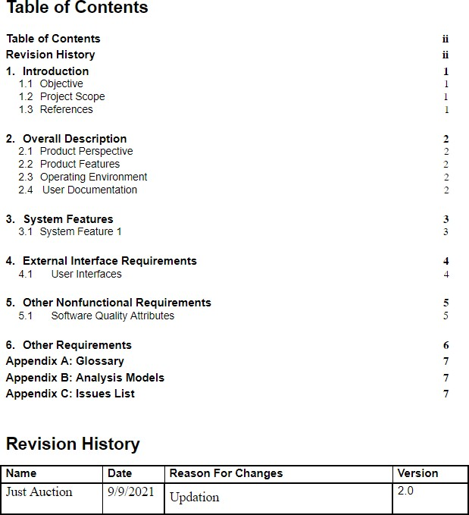**Revision History**

|  |  |  |  |
| --- | --- | --- | --- |
| **Name** | **Date** | **Reason For Changes** | **Version** |
|  |  |  |  |
|  |  |  |  |

# Introduction

## Artificial Intelligence is a technique of getting machines to work and behave like humans. For example: healthcare, marketing, business analytics, robotics etc. The concept of Artificial Intelligence was discovered by John McCarthy. Artificial intelligence refers to systems or machines that mimic human intelligence to perform tasks and can iteratively improve themselves based on the information they collect. AI manifests in a number of forms. A few examples are:

**Chat bots use AI to understand customer problems faster and provide more efficient answers**

**Intelligent assistants use AI to parse critical information from large free-text datasets to improve scheduling**

**Recommendation engines can provide automated recommendations for TV shows based on users’ viewing habits**

**AI is much more about the process and the capability for super-powered thinking and data analysis than it is about any particular format or function. Although AI brings up images of high-functioning, human-like robots taking over the world, AI isn’t intended to replace humans. It’s intended to significantly enhance human capabilities and contributions. That makes it a very valuable business asset.**

**Features of Artificial Intelligence are as follows:**

**Object detection**

**Natural processing language**

**Robotics**

**There are various types of Artificial Intelligence such as:**

**Artificial narrow intelligence**

**Artificial general intelligence**

**Artificial super intelligence**

**Alexa, face verification, autopilot feature at pilot, social human at Sophia, Google maps are some of the examples of Artificial Narrow Intelligence. Google Eye Doctor by Google, Recommendation system in the search engines are some of the application of Artificial Narrow Intelligence.**

**In today’s generation, 38% people are using virtual assistants which are built with the concept of Artificial Intelligence.**

**1.3 References**

Reference has been taken from some popular assistants like Alexa, Siri, etc.

Reference has also been taken from the AI Assistant builder tutorial from Google and YouTube

Reference Links(Only for References):

<https://www.udemy.com/course/learn-to-create-advance-ai-assistant-jarvis-20with-python/>

https://www.udemy.com/course/jarvis-ai/

Reference Articles:

<https://www.sciencedirect.com/science/article/pii/S0969698920312911>

<https://files.eric.ed.gov/fulltext/EJ1267812.pdf>

# Overall Description

# 2.2 Product Perspective

The main goal to build this project is to work smartly and save time for typing and searching on our own. It can take notes also so it makes our work easier and remember our important thing and meeting and remind us.

J.A.R.V.I.S is a standalone personal AI assistant that listens to your voice using Google’s Speech API and uses AI-generated speech to respond to your requests. Below are some other features of JARVIS -

- automate tasks like opening apps, searching on browsers like Google and Firefox, opening and editing files, writing emails, telling the time, sending email, setting reminders finding a location of your choice, etc. on your computer

- Give daily reports of your computer usage, internet usage, app usage, amount of time sitting down and can even give recommendations based on this data. An example would be - ‘you have been sitting on your computer for over an hour, go outside and take a break!’.

- allows you to schedule tasks to be done at a specific time. JARVIS will even remind you of certain tasks that need completing as those deadlines approach, making sure you don’t be late for anything! It can also go to offline mode whenever you require to close the application.

**2.2 Product features**

our assistant has the following features:

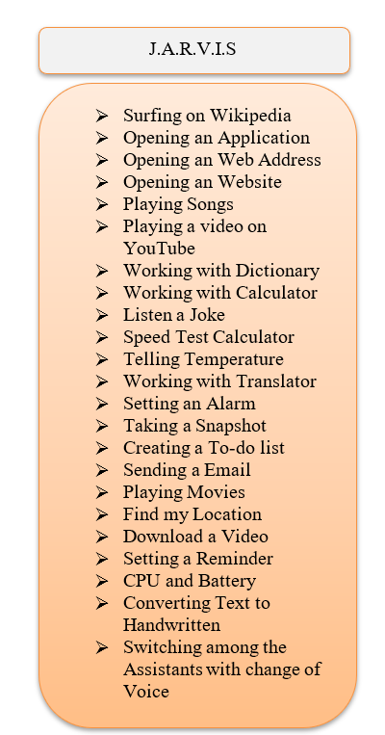

* **Searching summary on Wikipedia:**

If we want to search on Wikipedia and get a summary of something or place or some person, we can ask our ‘JARVIS’, it tells summary on whatever we ask

* **Open application / close application:**

It can open the application as we commanded and once we did our work it can close it

* **Open any web address:**

If we want to open some web address we can command to our ‘JARVIS’ it can open it for us

* **Open any website :**

Likewise opening web address features, can open any website

* **Play any song:**

It can open any song that you have downloaded. If you ask for a song and it’s not available on your pc it plays a song on YouTube

* **Play any videos on YouTube:**

It can open any video that you ask for

* **Search engine:**

You can search for anything on google by just asking

* **Dictionary:**

If there some word and you want to search it in the dictionary you can do it with the help of this function

* **Calculator:**

If we have any calculation like addition, subtraction, multiplication, or division it can perfume and tell us the answer

* **Telling joke:**

We ask to tell a joke and it tells us a joke that he found

* **Checking wi-fi speed:**

It can do a wifi speed test and tell us uploading speed and downloading speed

* **Temperature:**

It tells us the temperature of our location

* **Translator:**

It can translate anything in any language which you ask for

* **YouTube constellation:**

It can do YouTube control actions like to like the video, dislike the video, subscribes, etc

* **Set Alarm:**

It can set an alarm and it ringing until we command to stop the alarm

* **Taking a screenshot:**

It can take and screenshot and save it wherever you ask

* **Text to handwriting:**

This function like taking notes can convert speech to text, so it can use for taking notes in lectures

* **CPU and battery:**

It telling about our cup and battery

* **Changing speech rate:**

If with have to read something and the speed is not comfortable we can change it

* **Sent email:**

It can send an email by just taking command invoice

* **Play movie:**

If we have some movie download in our pc so we can play it by a given command

* **Location:**

it shows our location on google map and if you find any location in google map it can show you

* **My word repetition:**

If we have to repeat our word we can do

* **Remember function:**

It can remember anything that you ask to remember

* **Video downloader:**

You can download any video

## 2.3 Operating Environment

The operating environment for our assistant is as listed below.

Operating system: Windows, macOS.(sending email can’t be performed in macOS)

platform: python and AL base concept

## *2.6* User Documentation

In the About Us section of the project, there will be a brief description of the Showroom and the list of brands we are dealing with. The section will also consist of the showroom directions and a few glimpses of our showroom.

## 2.7 Assumptions and Dependencies

The main assumption of this project is that the user will be provided with ample information regarding sanitaryware products which will help the customer review our products and select the products they wish to purchase and the customer will be provided with a roughly estimated expenditure(Quotation).

# 3 System Features

## 3.1 System Feature 1

3.1.1 **Description and Priority**

3.1.2 **Stimulus/Response Sequences**

* + *Search for varieties of different sanitaryware products lightning products*
  + *Displays a detailed list of products along with images, dimensions, color, estimated price, list of brands.*
  + *Clients can generate quotations for the products they wish to buy.*

3.1.3 **Functional Requirements**

* The website should be able to display the products the user to see
* The website should be able to generate and estimate expenditure(quotation) for the products the customer has added.

# 4 External Interface Requirements

## 4.1User Interfaces

Front-end Software: Visual studio code, Bootstrap.

*4.2* **Hardware Interfaces**

*Windows*

*Browser which supports CSS,HTML,javascript*

## 4.3 Software Interfaces

*Following is the software used for our online showroom website.*

|  |  |
| --- | --- |
| ***Software used*** | ***Description*** |
| *Operating system* | *We have chosen Windows operating system for its best support and user-friendliness.* |
| *Database* | *To save the flight records, passenger records we have chosen the SQL+ database.* |
| *Visual studio code* | *To implement the project we have chosen HTML, CSS, javascript language for its more interactive support.* |

## 4.4 Communications Interfaces

This project supports all types of web browsers.

**5 Other Nonfunctional Requirements**

## 5.1 Performance Requirements

As the project is web-based there are no specifications for performance but in further updates of the project, the user will be able to select the products they wish to buy and will also be able to generate a rough expenditure(Quotation) for the products.

## 5.2 Safety Requirements

*<Specify those requirements that are concerned with possible loss, damage, or harm that could result from the use of the product. Define any safeguards or actions that must be taken, as well as actions that must be prevented. Refer to any external policies or regulations that state safety issues that affect the product’s design or use. Define any safety certifications that must be satisfied.>*

|  |  |  |  |  |
| --- | --- | --- | --- | --- |
| **3rd Sem** | **4th Sem** | **5th Sem** | **6th Sem** | **7th Sem** |
| Not Required | Not Required | Required, if requirement needs | Required, if requirement needs | Required, if requirement needs |

## 5.3 Security Requirements

*<Specify any requirements regarding security or privacy issues surrounding the use of the product or protection of the data used or created by the product. Define any user identity authentication requirements. Refer to any external policies or regulations containing security issues that affect the product. Define any security or privacy certifications that must be satisfied.>*

|  |  |  |  |  |
| --- | --- | --- | --- | --- |
| **3rd Sem** | **4th Sem** | **5th Sem** | **6th Sem** | **7th Sem** |
| Not Required | Not Required | Required, if requirement needs | Required, if requirement needs | Required, if requirement needs |

## 5.4 Software Quality Attributes

* ***AVAILABILITY:*** *Our retailed website is available 24*7.*
* ***CORRECTNESS:*** *The flight should reach starting from the correct start terminal and should reach the correct destination.*
* ***MAINTAINABILITY:*** *The administrators and flight chargers should maintain the correct schedules of flights.*
* ***USABILITY:*** *The flight schedules should satisfy a maximum number of customers’ needs.*

# Other Requirements

*<Define any other requirements not covered elsewhere in the SRS. This might include database requirements, internationalization requirements, legal requirements, reuse objectives for the project, and so on. Add any new sections that are pertinent to the project.>*

**Appendix A: Glossary**

*<Define all the terms necessary to properly interpret the SRS, including acronyms and abbreviations. You may wish to build a separate glossary that spans multiple projects or the entire organization, and just include terms specific to a single project in each SRS.>*

|  |  |  |  |  |
| --- | --- | --- | --- | --- |
| **3rd Sem** | **4th Sem** | **5th Sem** | **6th Sem** | **7th Sem** |
| If applicable | If applicable | If applicable | If applicable | If applicable |

**Appendix B: Analysis Models**

*<Optionally, include any pertinent analysis models, such as data flow diagrams, class diagrams, state-transition diagrams, or entity-relationship diagrams*.>

|  |  |  |  |  |
| --- | --- | --- | --- | --- |
| **3rd Sem** | **4th Sem** | **5th Sem** | **6th Sem** | **7th Sem** |
| If applicable | If applicable | If applicable | If applicable | If applicable |

**Appendix C: Issues List**

*< This is a dynamic list of the open requirements issues that remain to be resolved, including TBDs, pending decisions, information that is needed, conflicts awaiting resolution, and the like.>*

|  |  |  |  |  |
| --- | --- | --- | --- | --- |
| **3rd Sem** | **4th Sem** | **5th Sem** | **6th Sem** | **7th Sem** |
| If applicable | If applicable | If applicable | If applicable | If applicable |

*References*

[*https://krazytech.com/projects/sample-software-requirements-specificationsrs-report-airline-database*](https://krazytech.com/projects/sample-software-requirements-specificationsrs-report-airline-database)